CAMPUS RESIDENTIAL EXPERIENCES Assessment Brief #7, May 2015 Overview
The Housing and Residence Life Services survey is administered annually by Institutional Research and Decision Support (IRDS) to all UCM students living in campus residence halls. In February 2016, the survey was sent to 2046 residents and yielded a 35% response rate. The sample (N=722) captured this winter appears to be roughly representative of the on-campus resident population, except that females, Hispanic students and first year students were slightly overrepresented in this sample.
Methodology & Results:
The survey asks about the residential community experiences, about access to and information about campus resources and how they learn about programs and services. It asks about the physical environment: how clean the facilities are, how timely the staff responds to work orders. Students weigh in on the dining services, the OZZY machines, and their understanding of sustainability. They are asked about their impressions of safety in on-campus housing as well as the friendliness and helpfulness of the H&RL staff. They have a chance to identify three things they appreciate and three things they would like to change about their RA. Below, you will find some examples of responses to some of these questions. For more information, please contact H&RL.
Graph 1 provides responses to the questions: How important are these experiences to you?
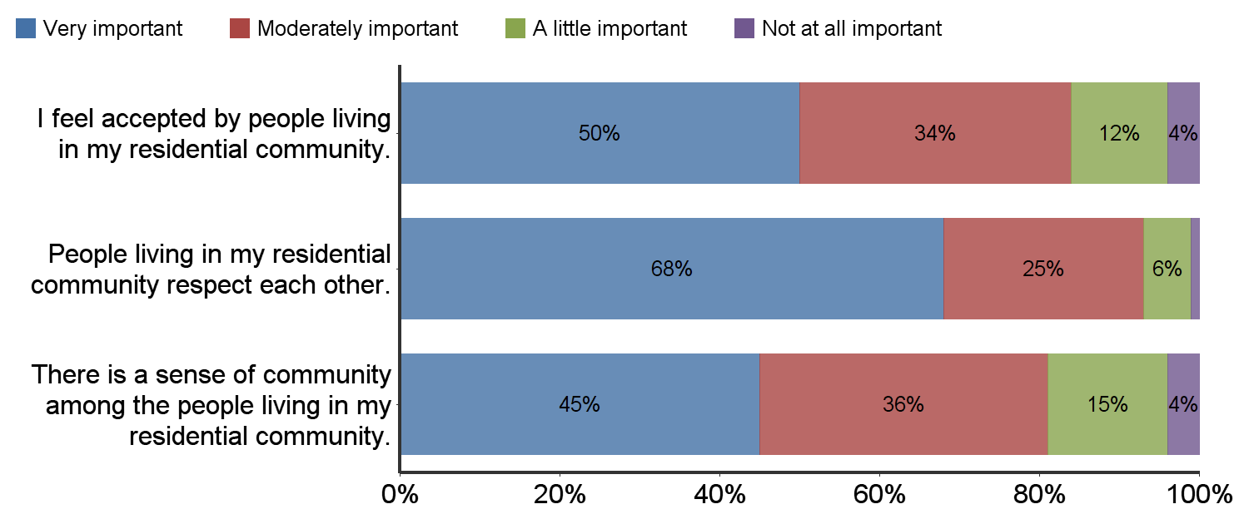

Graph 2 provides responses to the questions: To what extent do you agree or disagree with these statements?
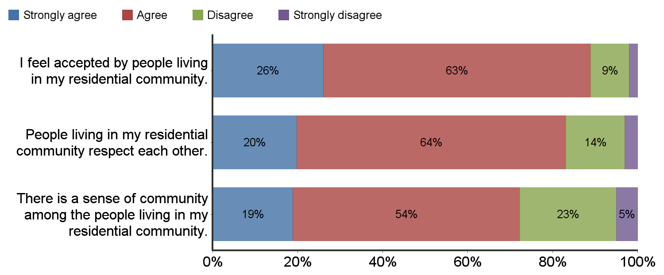
Graph 3 provides the same scale for questions about academic support, transition and success at UC Merced.
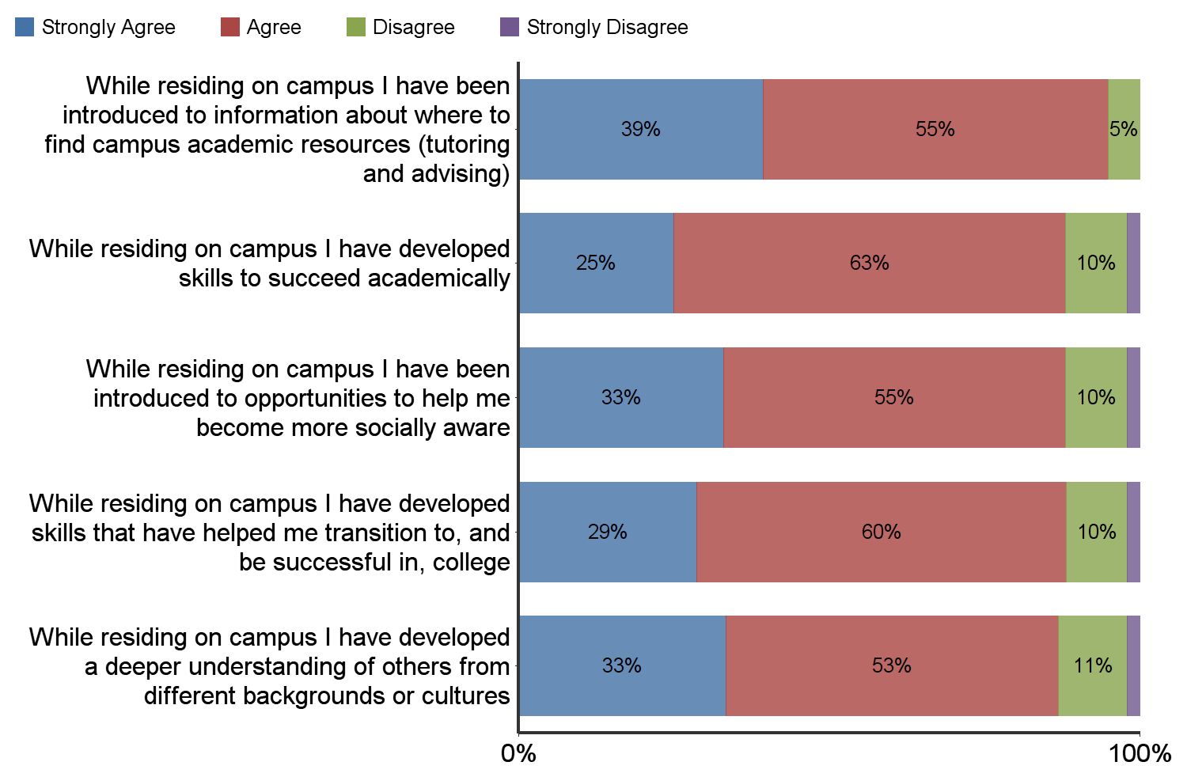

Graph 4, using the same agreement scale, directly addresses campus safety.
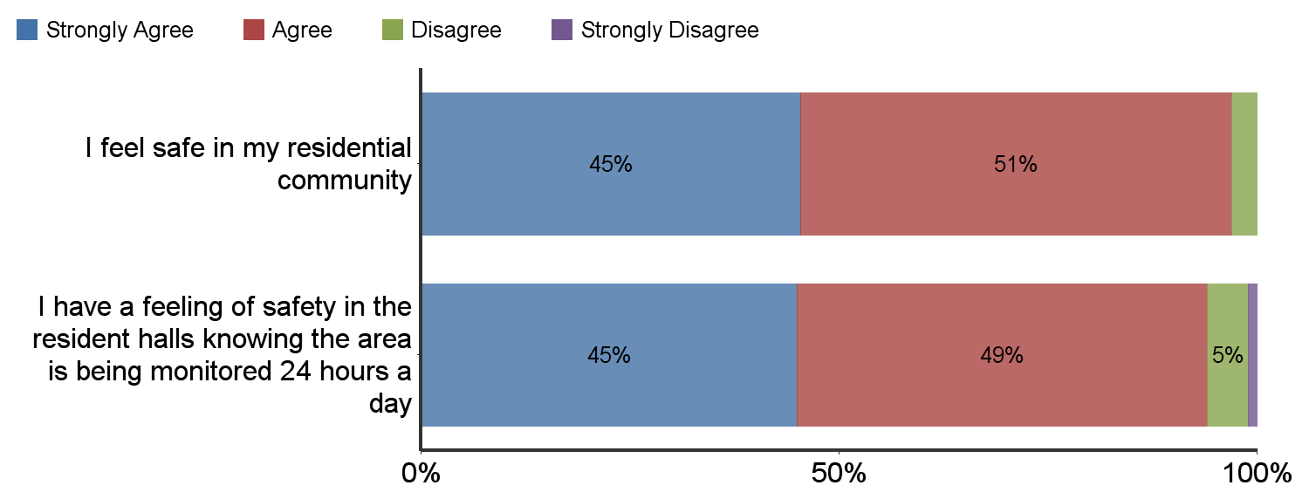

Summary

One pattern in the questions about residential community features (e.g., acceptance and respect) suggests a difference between how important the community values are and how much the students report experiencing those values. For example, half of the respondents (50%) say it is “very important” that they feel accepted by others living in their residential community (Graph 1) but only about a quarter (26%) of the respondents reported that they “strongly agree” that they are accepted by others living in their residential community (Graph 2).* The pattern holds for the concept of respect within the residential community: 68% of the respondents say that is “very important,” but only 20% say they “strongly agree” that people in their residential community respect each other. Perhaps the lesson is that while we hold these values to be important, it is harder to align large group behaviors to ensure our community consistently reflects those values.

Another observation of the results about how well the residential experience supports their academic goals (Graph 3) shows that consistently about 90% of the respondents provide positive feedback (strongly agree + agree) that living on campus has helped them find academic resources, develop academic skills, become more socially aware, transition and be successful in college, and deepen their understanding of human differences. Fairly consistently, about one third of the respondents “strongly agreed” their academic success was positive impacted by residing on campus.

Parting Shots: Want to know where residents currently get their information? Look no further! Now staff and student organizations can advertise their events in Happenings with confidence that they are reaching a good proportion of the residents!

Location of Information
Flyers on or near my door | 84%
Happenings Emails | 75%
In The House (email to residents only) | 69%
Word of mouth from other students | 56%
Posters/flyers in Dining Center | 53%
Posters/flyers near Mailroom, California Room or The Summits | 45%
Word of mouth from RA or PA | 44%
RA’s newsletter/bulletin board | 39%
Facebook posting | 28%
Event calendar on UCM website | 11%
Digital screens in Library | 6%
H&RL website | 5%
*However, combining the responses of those in agreement (strongly agree + agree), 89% of the respondents agree that they are accepted by the residential community, a very high proportion of the total.

