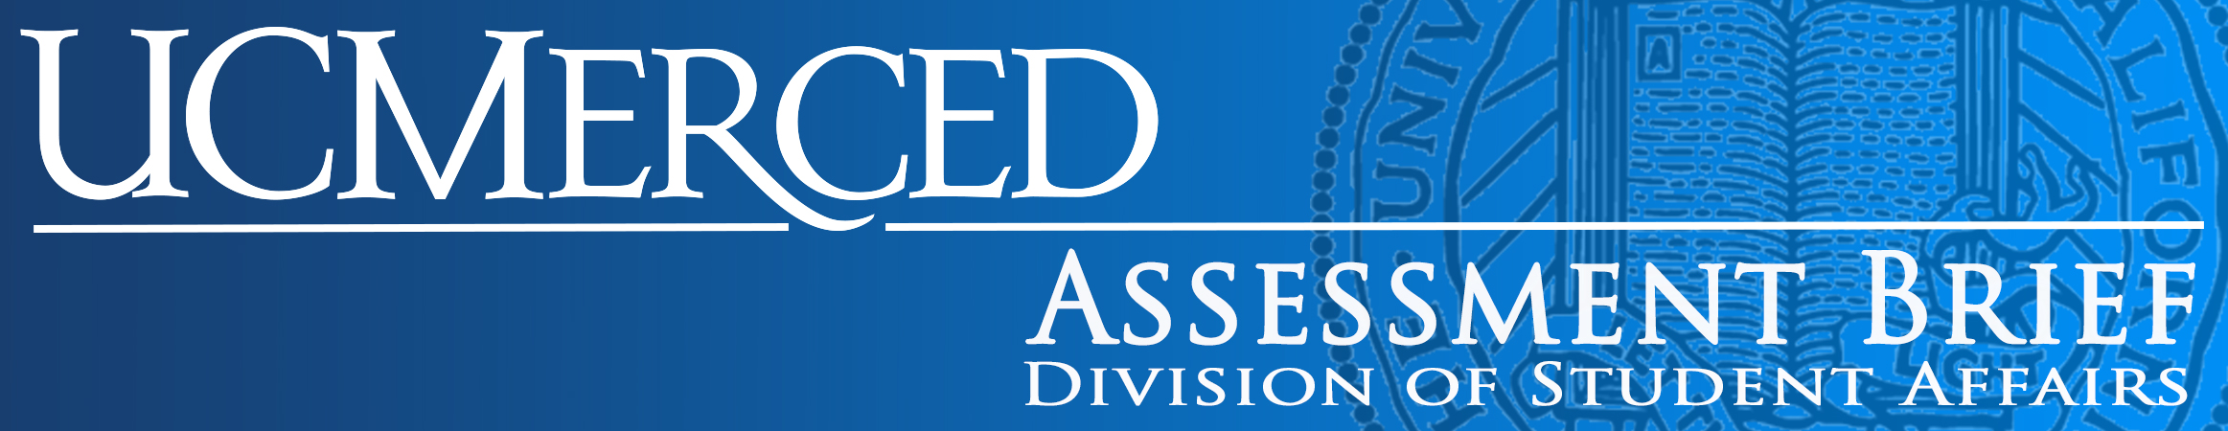

Graduating Senior Survey Assessment Brief #8, June 2016 Overview
Since 2009, UC Merced has surveyed undergraduates who graduated in fall, 2015 or indicated they plan to graduate in spring, 2016. In March, 2016, the survey was emailed to 1284 graduated/graduating seniors and kept open until May, yielding a response rate of 41% (N=522 respondents). The respondent sample was similar to the entire population of seniors, except women students were overrepresented, a common feature of survey samples at UC Merced (and nationwide). In addition to the characteristics tabled below, the sample is very similar to our student population in all race/ethnicity categories.
Demographic Characteristic | Graduated/Graduating  Senior Population | Graduated/Graduating  Senior Sample
Women students | 57% | 62%
Transfer students | 11% | 11%
First-generation college attendees | 63% | 60%
English-only speakers | 38% | 40%
Pell-eligible | 61% | 61%
Schools
Engineering | 15% | 15%
SSHA | 58% | 56%
Natural Sciences | 27% | 30%

Results
Graduating seniors were asked: Today, how connected to or disconnected from UC Merced do you feel? The results from the last five years of survey data are presented below. As you can see, since 2012, over 80% of the respondents have indicated they feel either “connected” or “very connected” in the spring of their last year of college. However, the line graph shows a slight downward trend over the past five years.
 | 2016 N = 522  41% Response Rate | 2015  N = 392  35% Response Rate | 2014 N = 477  42% Response Rate | 2013 N = 374  Response Rate Unavailable | 2012 N = 290  37% Response Rate
Very Connected | 27% | 23% | 25% | 26% | 32%
Connected | 55% | 59% | 59% | 63% | 54%
Disconnected | 13% | 14% | 14% | 9% | 11%
Very Disconnected | 4% | 3% | 3% | 2% | 3%

Class of 2016 Self-Reported Post-Graduation Plans
Continuing employment in my current job | 10%
Accepted full-time employment with new employer | 9%
Accepted part-time employment with new employer | 4%
Accepted an internship | 5%
Reviewing job offer | 10%
Starting my own business | 1%
Starting public service (military, Peace Corps, Teach for America) | 1%
Accepted to graduate/professional school | 8%
Applied to graduate/professional school but not been accepted yet | 10%
Continuing my education but not in graduate/professional school | 15%
Taking time off before finding a job | 17%
Searching for full-time employment | 50%
Searching for part-time employment | 22%
No plans for work | 2%

N.B. Percentages total more than 100% because respondents were allowed to “check all that apply” on survey.

Research Opportunities
In 2016, almost a third of the respondents (31%) reported conducting research with a faculty member while at UC Merced, and of those respondents, 35% of them presented their research findings outside the classroom at a conference or in a publication. In 2012, 38% of the survey respondents reported being involved in research with a faculty member, and 32% of those conducting research indicating they presented their results outside the classroom. Seniors appear to report having participated in research with faculty less in 2016 when 1284 students graduated than in 2012 when 776 students graduated. However, rates of student researchers who presented their research outside the classroom were similar across years.

Conclusions
The bulk of the survey is dedicated to the academic experiences of our graduating seniors. The survey asks about their experiences with our library, and the general education program and then provides questions about the respondents’ majors. The results are summarized and shared with the Schools. Many of the academic programs use this indirect evidence in their period program reviews and annual assessment of their program learning outcomes.
One reminder this data set offers is that roughly 38% have solid post-graduation plans, and so over half of our graduating class is actively looking for employment at the end of their undergraduate experience. This means that while all those Bobcats are considered alumni, many of them may still need the support of CCPA and of the Student Affairs staff who serve as mentors and former supervisors who might provide references or even pep talks as they navigate their entrance into the world of work.
Thanks so much to all of you who helped promote the Graduating Senior Survey this year to ensure a good response rate! To view the full reports from these surveys on the IRDS website, please visit: http://irds.ucmerced.edu/graduating%20senior%20survey.html.

